**EXECUTIVE SUMMARY REPORT 1**

ALY6000 Introduction to Analytics Module 1 Project 1

KAUSHAL .N.PAREKH

College of Professional Studies, Northeastern University

Prof. Satter

11/01/2025

**CODING WITH OUTPUT SCREEN-SHOT**

**1)Write lines of code to compute all of the following**.













**2) Create a vector using the c function with the values 17, 12, -33, 5 and assign it to a variable called first_vector.**



**3) Create a vector using the c function with the values 5, 10, 15, 20, 25, 30, 35 and assign it to a variable called counting_by_fives.**

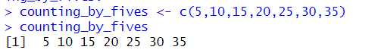

**4) Create a vector using the range operator (the colon), that contains the numbers from 20 down to 1. Store the result in a variable called second_vector.**



**5) Create a vector using the range operator that contains the number from 5 to 15. Store the result in a variable called counting_vector.**

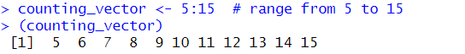

**6) Create a vector with the values (96, 100, 85, 92, 81, 72). Store the result in a variable called grades.**

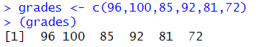

**7) Add the number 3 to the vector grades. Store the result in a variable called bonus_points_added.**

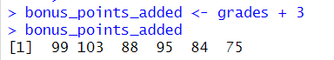

**8) Create a vector with the values 1 – 100 and store it in a variable called ne_to_one_hundred. Do not type out all 100 numbers.**

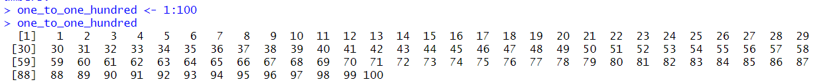

**9) Write each of the following lines of code. Add a one-sentence comment above each line explaining what is computed.**





**10) Using the built-in sum function, compute the sum of one_to_one_hundred. Store the result in a variable called total.**



**11) Using the built-in mean function, compute the average of one_to_one_hundred. Store the result in a variable called average_value.**

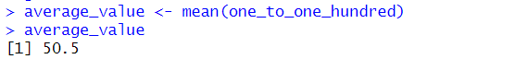

**12) Using the built-in median function, compute the average of one_to_one_hundred. Store the result in a variable called median_value.**

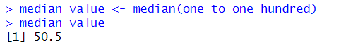

**13) Using the built-in max function, compute the max of one_to_one_hundred. Store the result in a variable called max_value.**



**14) Using the built-in min function, compute the min of one_to_one_hundred. Store the result in a variable called min_value.**



**15) Using brackets, extract the first value from second_vector and store it in a variable called first_value.**



**16) Using brackets, extract the first, second and third values from second_vector. Store the result in a variable called first_three_values.**



**17) Using brackets, extract the 1st, 5th, 10th, and 11th elements of second_vector. Store the resulting vector in a variable called vector_from_brackets**



**18) Use the brackets to extract elements from first_vector using the vector c(FALSE, TRUE, FALSE, TRUE). Store the result in a variable called vector_from_boolean_brackets**



**19) Examine the following code and write a one-sentence comment explaining what is happening. (second_vector >= 10)**



**20) Extract values from one_to_one_hundred that are greater than or equal to 20. Ans: - one_to_one_hundred[one_to_one_hundred >= 20]**



**21) Create a new vector from the grades vector with only values larger than 85. Store the result in a variable called lowest_grades_removed.**



**22) Remove the 3rd and 4th elements of grades. Store the result in a variable called middle_grades_removed**.



**23) Remove the 5th and 10th elements of second_vector. Store the result in a variable called fifth_vector.**



**24) Generate a random vector using set.seed() and runif.()**



**25) Compute the sum of random_vector.**



**26) Compute the cumulative sum of random_vector.**



**27) Compute the mean of random_vector.**



**28) Compute the standard deviation of random_vector.**



**29) Round the values of random_vector.**



**30) Sort the values of random_vector.**



**31) Download the datafile ds_salaries.csv from Canvas and save it in the same folder where your .R file is located.**

**32) Use the read.csv function to read ds_salaries.csv.**



**33) Use the summary function with first_dataframe to produce summary statistics for each column.**

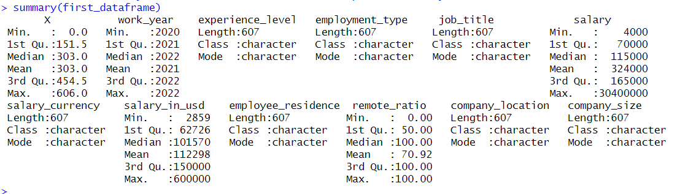

**CONCLUSION :**

In summary, completing this project has significantly improved my skills and comprehension of the R programming language. Through practical activities, I have gained valuable experience in handling vectors, conducting diverse statistical analyses, and managing CSV files. This hands-on practice has boosted my confidence in using R for real-world data analysis challenges.

**Reference:**

Kabacoff, R. I. (2015). *R in action: Data analysis and graphics with R* (2nd ed.). Manning Publications. OpenAI. (2023). *ChatGPT* (Jan 2023 version) https://chatgpt.com